9. TRANSIT ACCOMMODATIONS

INTRODUCTION 1
ESSENTIAL PRINCIPLES OF DESIGNING STREETS FOR TRANSIT 1
ACCESS TO TRANSIT 2
BUS STOPS 3
Layout 3
Transit-Specific Streetscape Elements 4
BUS STOP PLACEMENT 6
Bus Stop Zone Design 7
Curbside Bus Stops 8
Bus Bulbs 9
Characteristics 10
Queue Jumper Bus Bay 11
Partial Open Bus Bays 12
SIGNAL TREATMENT 12
Queue Jumpers 13
MINIMUM TURN RADIUS 14
URBAN DESIGN 16
BICYCLE CONNECTIONS 16
BUS LANES 16
ACCOMODATING LIGHT RAIL, STREET CARS, and BRT 17

INTRODUCTION
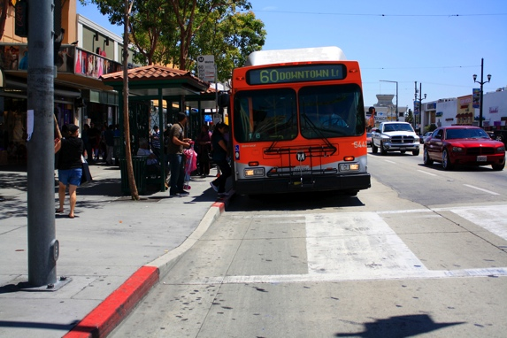
Bus stops should
be designed for passengers
(Credit: Sky Yim)
Public transit serves a vital transportation function for many people; it is their access to jobs, school, shopping, recreation, visitation, worship, and other daily functions. Except for subways and rail lines on exclusive rights-of-way, most transit uses streets. For transit to provide optimal service, streets must accommodate transit vehicles as well as access to stops. Transit connects passengers to destinations and is an integral component of shaping future growth into a more sustainable form. Transit design should also support placemaking.

This chapter provides design guidance for both transit stops and transit operating in the streets, including bus stop layout and placement and the use of bus bulbs and transit lanes. The chapter ends with a discussion of ways to accommodate light rail, street cars, and Bus Rapid Transit (BRT).

ESSENTIAL PRINCIPLES OF DESIGNING STREETS FOR TRANSIT
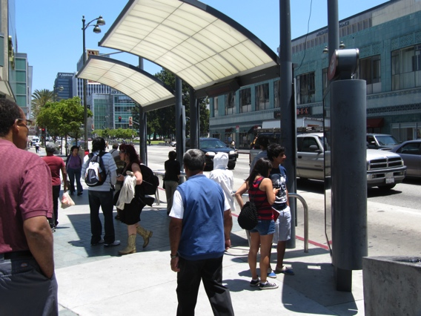
Bus stops are centers of activity (Credit: Ryan Snyder)
Public transit should be planned and designed as part of the street system. It should interface seamlessly with other modes, recognizing that successful transit depends on customers getting to the service via walking, bicycling, car, taxi, or paratransit. Transit should be planned following these principles:

- Transit has a high priority on city streets. On some streets, transit vehicles should have higher priority than private vehicles.
- The busiest transit lines should have designated bus lanes.
- Where ridership justifies, some streets, called transit malls, may permit only buses or trains in the travelled way. These often also allow bicycles.
- Technology should be applied to increase average speeds of transit vehicles where appropriate.
- Transit stops should be easily accessible, with safe and convenient crossing opportunities.
- Transit stops should be active and attractive public spaces that attract people on a regular basis, at various times of day, and all days of the week.
- 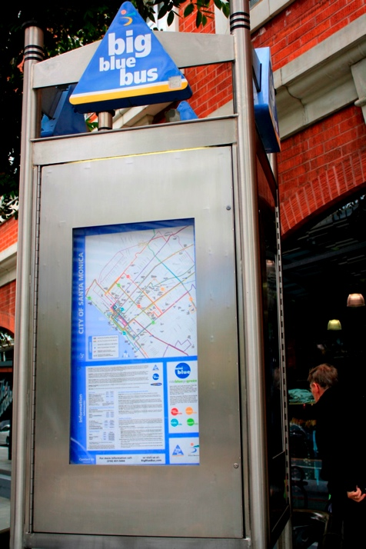Transit stops function as community destinations. The largest stops and stations should be designed to facilitate programming for a range of community activities and events.
Examples of bus stop amenities (Credit: Sky Yim)
- Transit stops should include amenities for passengers waiting to board.
- Transit stops should provide space for a variety of amenities in commercial areas, to serve residents, shoppers, and commuters alike.
- Transit stops should be attractive and visible from a distance.
- Transit stop placement and design influences accessibility to transit and network operations, and influences travel behavior/mode choice.
- Zoning codes, local land use ordinances, and design guidelines around transit stations should encourage walking and a mix of land uses (see Chapter 13, “Designing Land Use along Living Streets”).
- Streets that connect neighborhoods to transit facilities should be especially attractive, comfortable, and safe and inviting for pedestrians and bicyclists.

ACCESS TO TRANSIT

Transit depends primarily on walking to function well; most transit users walk to and from transit stops. Sidewalks on streets served by transit and on the streets that lead to transit corridors provide basic access. Bicycle-friendly streets do the same for those who access transit by bicycle.

Every transit trip also requires a safe and convenient street crossing at the transit stop; a disproportionally high number of pedestrian crossing crashes occur at transit stops. Every transit stop should be evaluated for its crossing opportunities. If the crossing is deemed unsafe, mitigation can occur in two ways: a crossing should be provided at the existing stop, or the stop can be moved to a location with a safer crossing. For street crossing measures, see Chapter 7, “Pedestrian Crossings.” Simply stated, there should not be transit stops without means to safely and conveniently cross the street.

But simply moving a stop is not always a service to transit users who may have to walk further to access their stop. Convenient access by passengers must remain at the forefront of all transit stop planning: eliminating stops because they are perceived as unsafe will not be satisfactory to riders who cannot walk very far. But eliminating or consolidating stops can be beneficial to transit operations and users by reducing the number of times a bus, streetcar, or light rail train has to stop. The trade offs are added walking time for users but reduced transit operator delay, resulting in a shorter journey overall. For example, this might mean a two to three minute longer walk for some passengers but an eight to 10 minute shorter bus ride for all.

BUS STOPS

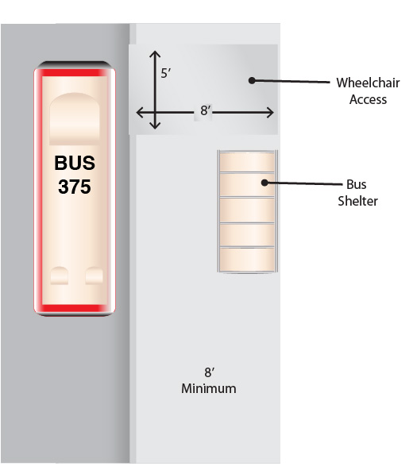
The following sections provide guidance for designing bus stops.

Layout

A well placed and configured transit stop offers the following characteristics:

- Clearly defines the stop as a special place
- Provides a visual cue on where to wait for a transit vehicle
- Does not block the path of travel on the adjacent sidewalk
- Allows for ease of access between the sidewalk, the transit stop, and the transit vehicle
ADA compliant bus stop
(Credit: Michele Weisbart)

Layout guidelines include the following:

- Consolidate streetscape elements to create a clear waiting space and minimize obstructions between the sidewalk, waiting area, and boarding area
- Consider the use of special paving treatments or curb extensions (where there is on-street parking) to distinguish transit stops from the adjacent sidewalks
- Integrate transit stops with adjacent activity centers whenever possible to create active and safe places
- Avoid locating bus stops adjacent to driveways, curb cuts, and land uses that generate a large number of automobile trips (gas stations, drive-thru restaurants, etc.)

Transit stops are required by the Americans with Disabilities Act (ADA) to be accessible. Specifically, ADA requires a clear loading area (minimum 5 feet by 8 feet) perpendicular to the curb with a maximum 2 percent cross-slope to allow a transit vehicle to extend its lift to allow people with disabilities to board. The loading area should be located where the transit vehicle has its lift and be accessible directly from a transit shelter. The stop must also provide 30 by 40 inches of clear space within a shelter to accommodate wheelchairs. The greater use of low-floor transit vehicles may make this requirement moot; but it will still be necessary to provide enough room so wheelchair users can access all doors.

Transit-Specific Streetscape Elements

The essential streetscape elements for transit include signs, shelters, and benches.

Flag signs indicate where people are to wait and board a transit vehicle. The signs should clearly identify the transit operator, route number, and schedule. Maps showing the transit lines servicing that stop, local destinations, and additional transfer transit lines should also be provided. Flag signs should be located towards the front of the stop

Benches should be provided at transit stops with headways longer than five minutes.

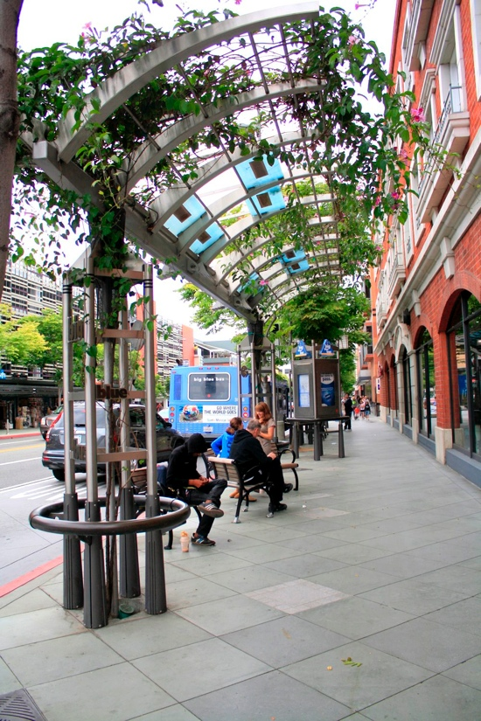Shelters keep waiting passengers out of the rain and sun and provide increased comfort and security. Shelters vary in size and design; standard shelters are 3 to 7 feet wide and 6 to 16 feet long. They include covered seating and sign panels that can be used for transit information. Shelters should
Bus stop shelter
(Credit: Sky Yim)

- Be provided at transit stops with headways longer than 10 minutes
- Have electrical connections to power lighting and/or real-time transit information, or accommodate solar power
- Be set back from the front of the bus stop to allow for the bus to merge into travel lanes when the stop is located at the far side of an intersection or at a mid-block location. This setback is not required when the stop is located at the near side of the intersection or at a bus bulb.

Shelters should be located in a sidewalk’s furniture zone so they don’t conflict with the pedestrian zone. Shelters may be placed in the sidewalk’s frontage zone provided that they do not block building entrances or the pedestrian zone.

Transit stops should also provide other amenities to make waiting for the next bus comfortable:

- Trash/recycling receptacles should be provided and maintained at most stops.
- 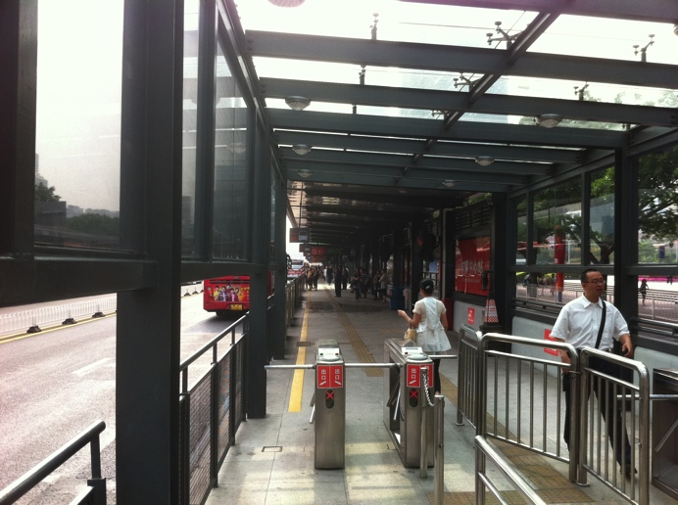Depending on headways and the number of passengers boarding and alighting, electronic “next bus” readouts can be used to inform passengers when to expect the next bus.
Pre-board fare payment
system: Guangzhou, China
(Credit: Ryan Snyder)
- Very busy bus stops and transit stations should include space for vendors to sell newspapers, magazines, flowers, and other goods to keep the stops lively.
- Rapid bus lines can include facilities that allow passengers to pay their fare before boarding the bus. Along with wide doors on buses, this allows buses to reduce their travel time by reducing dwell time at stops.

BUS STOP PLACEMENT

A bus stop’s optimal placement depends on the operational characteristics of both the roadway and the transit system. The placement of bus stops at the far side of signalized intersections is generally considered to be preferable to near side or mid-block locations. However, each location has its advantages and disadvantages, as shown in Table 9.1.

Table 9.1 Bus Stop Placement Considerations

Location | Advantage | Disadvantage
Near Side | - Minimizes interference when traffic is heavy on the far side of an intersection  - Provides an area for a bus to pull away from the curb and merge with traffic  - Minimizes the number of stops for buses  - Allows passengers to board and alight while the bus is stopped at a red light  - Allows passengers to board and alight without crossing the street if their destination is on the same side of the street. This is most important where one side of the street has an important destination, such as a school, shopping center, or employment center that generates more passenger demand than the far side. | - Increases conflicts with right-turning vehicles  - Stopped buses may obscure curb-side traffic control devices and crossing pedestrians  - Obscures sight distances for vehicles crossing the intersection that are stopped to the right of the buses  - Decreases roadway capacity during peak periods due to buses queuing in through lanes near bus stops  - Decreases sight distance of on-coming traffic for pedestrians crossing intersections  - Can delay buses that arrive during the green signal phase and finish boarding during the red phase  - Less safe for passengers crossing in front of the bus
Far Side | - Minimizes conflicts between right-turning vehicles and buses  - Optimal location for traffic signal synchronized corridors  - Provides additional right-turn capacity by allowing traffic to use the right lane  - Improves sight distance for buses approaching intersections  - Requires shorter deceleration distances for buses  - Signalized intersections create traffic gaps for buses to reenter traffic lanes  - Improves pedestrian safety as passengers cross in back of the bus | - Queuing buses may block the intersection during peak periods  - Sight distance may be obstructed for vehicles approaching intersections  - May increase the number of rear-end accidents if drivers do not expect a bus to stop after crossing an intersection  - Stopping both at a signalized intersection and a far-side stop may interfere with bus operations
Mid-Block | - Minimizes sight distance problems for pedestrians and vehicles  - Boarding areas experience less congestion and conflicts with pedestrian travel paths  - Can be located adjacent to or directly across from a major transit midblock use generator | - Decreases on-street parking supply (unless mitigated with a curb extension)  - Requires a mid-block pedestrian crossing  - Increases walking distance to intersections  - Stopping buses and mid-block pedestrian crossings may disrupt mid-block traffic flow
Source: Federal Transit Administration, BRT Stops, Spacing, Location, and Design, www.fta.dot.gov/research_4361.html

In general, bus stops should be located at the far side of a signalized intersection in order to enhance the effectiveness of traffic signal synchronization or bus signal priority projects. Near-side bus stops are appropriate for stop sign-controlled intersections. But in all cases priority should be given to the location that best serves the passengers.

Bus Stop Zone Design

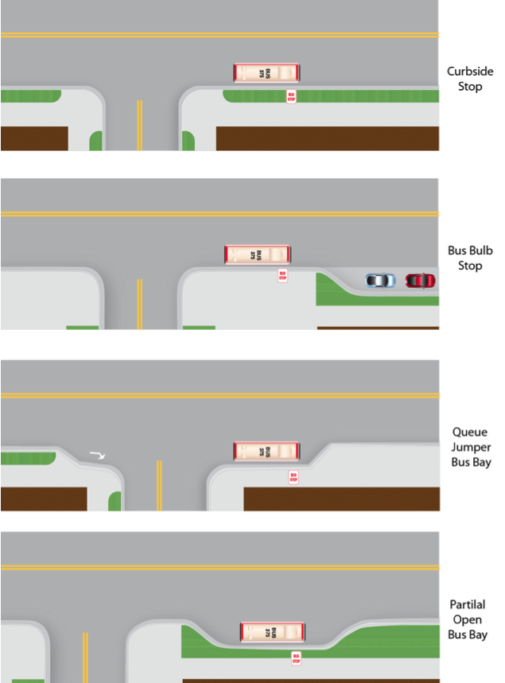This section provides guidance for designing the bus stop zone, the portion of the street where passengers load and unload. The guidelines provided allow for customization depending on the location. A significant number of these guidelines come from the Transit Cooperative Research Program Report 19, Guidelines for the Location and Design of Bus Stops, prepared by the Transportation Research Board and National Research Board and sponsored by the Federal Transit Administration. The length and configuration of a bus stop zone varies depending on the type of bus stop. Bus stop zones should be marked.
Common Types of Bus Stops
(Credit: Michele Weisbart)

The following pages provide guidance for designing the bus stop zones for four typical kinds of bus stops: curbside bus stops, bus bulbs, queue jumper bus bays, and partial open bus bays.

Curbside Bus Stops

Curbside bus stops have no curb extensions or cut outs. They provide easy access for bus drivers, are simple and inexpensive, and are easy to relocate. However, where they block the travel lane they can cause traffic to queue behind, and where they don’t block the travel lane bus drivers may have difficulty re-entering traffic.

Where articulated buses operate, an additional 20 feet should be added to the length of the bus stop zone. Where multiple buses may queue, the bus stop zone should be extended by 50 feet for each standard 40-foot bus, and by 70 feet for each additional 60-foot articulated bus.

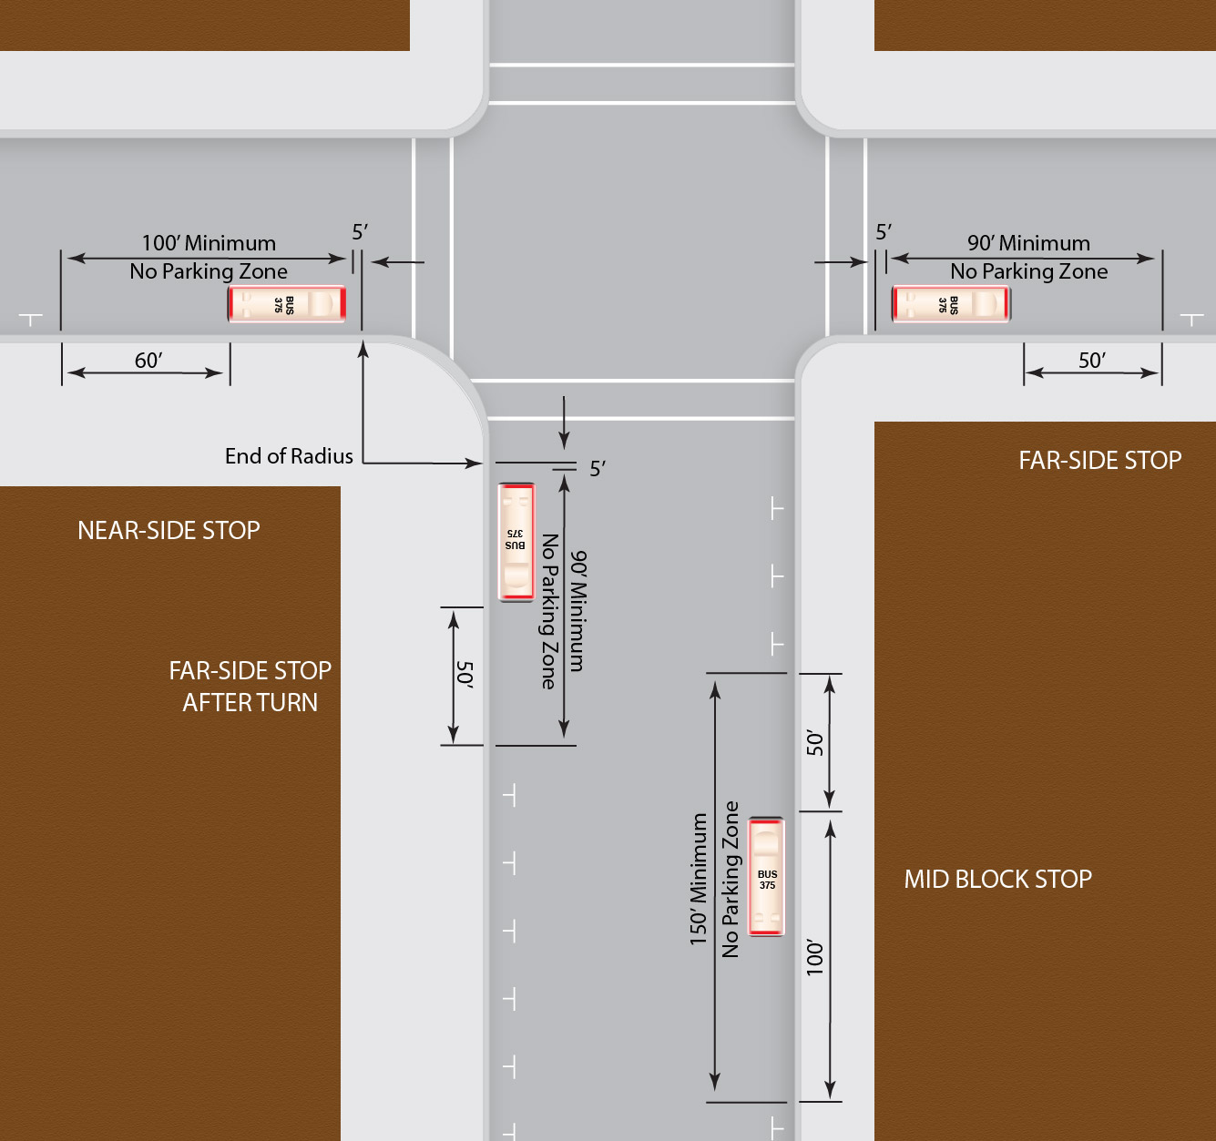
Typical Dimensions for Curbside Bus Stop Zones
(Credit: Michele Weisbart)

Bus Bulbs

Bus bulbs are curb extensions that extend the length of the transit stop on streets with on-street parking. They improve transit performance by eliminating the need for buses to merge into mixed traffic after every stop. They also facilitate passenger boarding by allowing the bus to align directly with the curb; waiting passengers can enter the bus 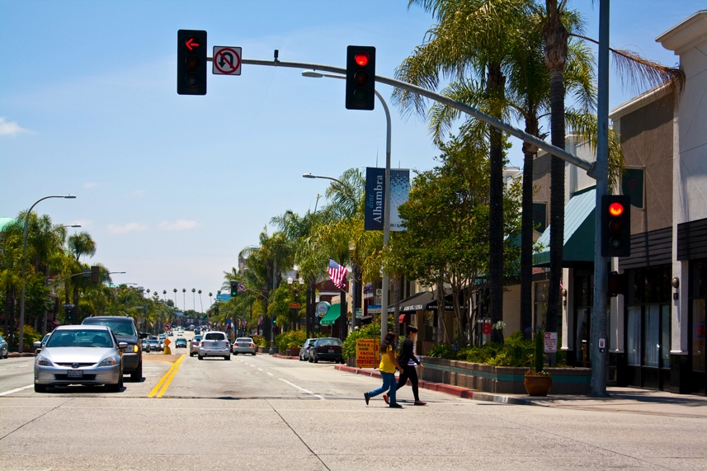immediately after it has stopped. They improve pedestrian conditions by providing additional space for people to wait for transit and by allowing the placement of bus shelters where they do not conflict with a sidewalk’s pedestrian zone. Bus bulbs also reduce the crossing distance of a street for pedestrians if they are located at a crossing. In most situations, buses picking up passengers at bus bulbs block the curbside travel lane; but this is mitigated by the reduced dwell time, as it takes less time for the bus driver to position the bus correctly, and less time for passengers to board.
Bus bulb: Alhambra, CA (Credit: Sky Yim)

One major advantage of bus bulbs over pulling over to the curb is that they require less parking removal: typically two on-street parking spots for a bus bulb instead of four for pulling over.

The following conditions should be given priority for the placement of transit bus bulbs:

- Where transit performance is significantly slowed by the transit vehicle’s merging into a mixed-flow travel lane
- Roadways served by express or Bus Rapid Transit (BRT) lines
- Stops that serve as major transfer points
- Areas with heavy transit and pedestrian activity and where narrow sidewalks do not allow for the placement of a bus shelter without conflicting with the pedestrian zone

Bus bulbs should not be considered for stops with any of the following:

- A queue-jumping lane provided for buses
- On-street parking prohibited during peak travel periods
- Near-side stops located at intersections with heavy right-turn movements, except along streets with a “transit-first” policy
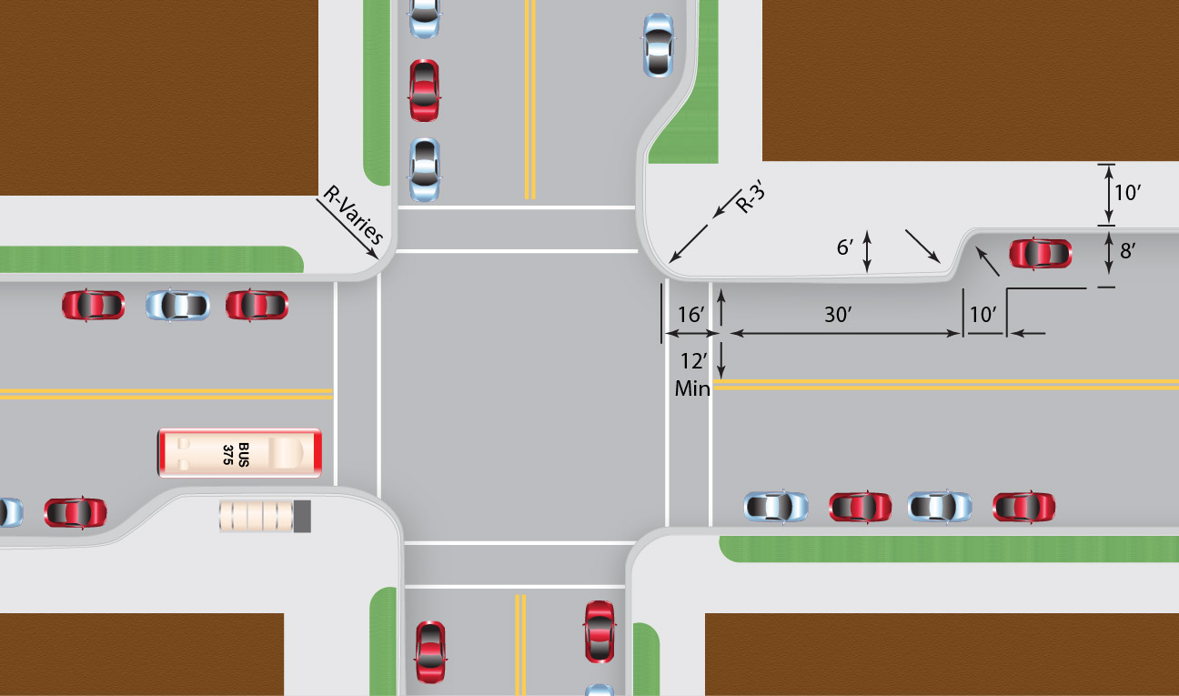
Typical Dimensions for Bus Bulb Bus Stop Zones
(Credit: Michele Weisbart)

Characteristics

At a minimum, bus bulbs should be long enough to accommodate all doors of a transit vehicle to allow for the boarding and alighting of all passengers, or be long enough to accommodate two or more buses (with a 5-foot clearance between buses and a 10-foot clearance behind a bus) where there is frequent service such as with BRT or other express lines. Bus bulbs located on the far side of a signalized intersection should be long enough to accommodate the complete length of a bus so that the rear of the bus does not intrude into the intersection.

Table 9.2 Standard Transit Vehicle and Transit Bus Bulb Dimensions

Vehicle | Length (feet) | Number of Buses at Stop | Platform Length (feet)
 |  |  | Near Side | Far Side
Standard bus | 40 | 1 | 35 | 45
 |  | 2 | 55 | 65
Articulated bus | 60 | 1 | 80 | 90
 |  | 2 | 120 | 130
Federal Transit Administration, August 2004. Characteristics of Bus Rapid Transit for Decision Making Project NO: FTA-VA-26-7222-2004.1

Queue Jumper Bus Bay

Queue jumper bus bays allow buses to bypass queued traffic and take advantage of queue jumper signals, which give them a head start across the intersection. A queue jumper bus bay is a dedicated bus lane extending for a short distance at both sides of the intersection. Queue jumper bus bays are not needed with queue jumper signals where bus lanes exist. Queue jumper bus bays are most useful in the following situations:

- Along bus routes with short headways
- Where traffic volumes exceed 250 vehicles per hour in the curb lane during the peak hour
- At congested intersections (suggested where conventional Level of Service is “D” or worse)
- Where the physical space for the lane exists and creating the bay isn’t too costly

The stopping area length should be 50 feet for each standard 40-foot bus, and 70 feet for each 60-foot articulated bus expected to be simultaneously stopped. The dimensions shown for the length of the exit taper, acceleration lane, and entrance taper are based on a through speed of 35 mph. These can be decreased with lower speeds and should increase with higher speeds. The entrance taper should be at least 5:1 and the exit taper not sharper than 3:1.

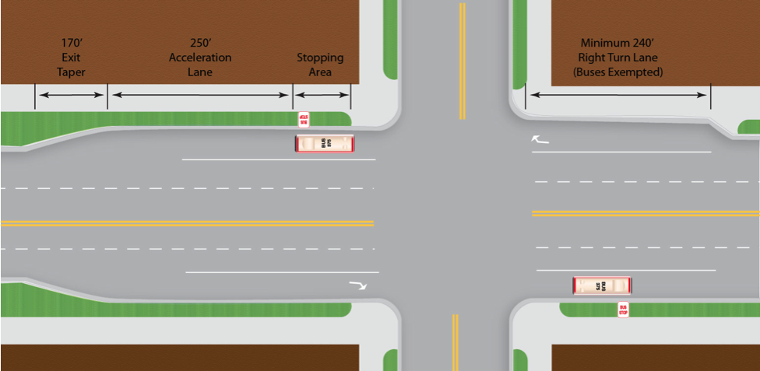
Typical Dimensions for Queue Jumper Bus Bay Zones
(Credit: Michele Weisbart)

Partial Open Bus Bays
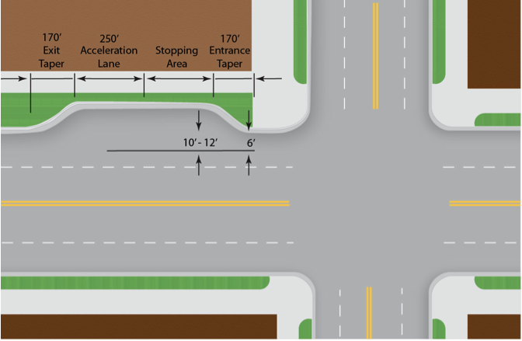
Typical Dimensions for Partial Open Bus Bay Zones
(Credit: Michele Weisbart)
Partial open bus bays provide a curb extension to assist pedestrians, many of whom may be bus passengers, across the street. They also prevent right-turning vehicles from using the bus bay for acceleration. The bays have the disadvantage of requiring buses to merge into traffic when they re-enter the travel lane.

The stopping area length should be 50 feet for each standard 40-foot bus, and 70 feet for each 60-foot articulated bus expected to be simultaneously stopped. The dimensions shown for the length of the exit taper, acceleration lane, and entrance taper are based on a through speed of 35 mph. These can be decreased with lower speeds and should increase with higher speeds. The entrance taper should be at least 5:1 and the exit taper not sharper than 3:1.

SIGNAL TREATMENT

Signal prioritization is a component of technology-based “intelligent transportation systems” (ITS). These systems are often used by road authorities in conjunction with transit agencies to help improve a roadway system’s overall operations in the following ways:

- Reduce traffic signal delays for transit vehicles
- Improve an intersection’s person throughput
- Reduce the need for transit vehicles to stop for traffic at intersections
- Help reduce transit vehicles’ travel time
- Help improve transit system reliability and reduce waiting time for people at transit stops

Signal prioritization projects include signal timing or phasing projects and transit signal priority projects.

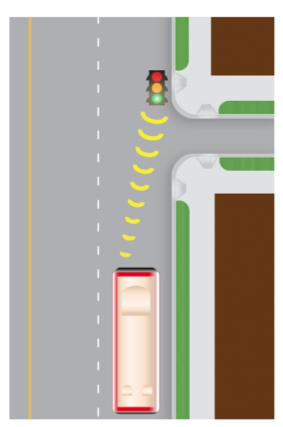Signal timing projects optimize the traffic signals along a corridor to make better use of available green time capacity by favoring a peak directional traffic flow. These passive systems give priority to roadways with significant transit use within a district-wide traffic signal timing scheme. Transit signal prioritization can also be achieved by timing a corridor’s traffic signals based on a bus’s average operating speed instead of an automobile’s average speed.
Signal-priority technology can help to reduce delay for buses
(Credit: Michele Weisbart)

Transit signal-priority projects alter a traffic signal’s phasing as a transit vehicle approaches an intersection. This active system requires the installation of specialized equipment at an intersection’s traffic signal controller and on the transit vehicle. It can either give an early green signal or hold a green signal that is already being displayed in order to allow buses that are operating behind schedule to get back on schedule. Signal-priority projects also help improve a transit system’s schedule adherence, operating time, and reliability.

Although they may use similar equipment, signal-priority and pre-emption are two different processes. Signal-priority modifies the normal signal operation process to better accommodate transit vehicles, while signal pre-emption interrupts the normal signal to favor transit or emergency vehicles.

The placement of a bus stop at the far side of a signalized intersection increases the effectiveness of transit signal-priority projects. Signal treatments should be used along streets with significant bus service.

Queue Jumpers

Queue jumpers give preference to buses at signalized intersections with a special phase in the traffic signal that allows buses a head start in crossing the intersection. They are used on dedicated bus lanes and where a special queue jumper lane provides an opportunity for buses to circumvent congestion at the intersection. (See Queue Jumper Bus Bay section)

MINIMUM TURN RADIUS

Where bus routes make right turns, it is important to ensure adequate turn radii of the curbs to enable the buses to turn without difficulty. The following diagrams illustrate the needed turning radii for a 40-foot bus, a 45-foot bus, and a 60-foot articulated bus. They are taken from the Los Angeles County Metropolitan Transportation Authority Standard Data Sheets. Note that on-street parking, bike lanes, and wide curb lanes effectively expand a curb’s available radius.
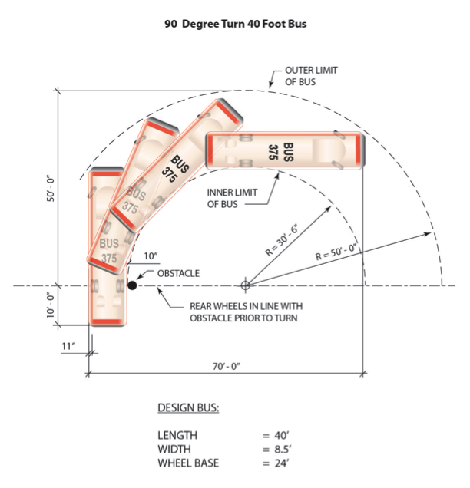
Minimum Turning Radius for 40-foot Bus Making 90-Degree Turn
(Credit: Michele Weisbart)

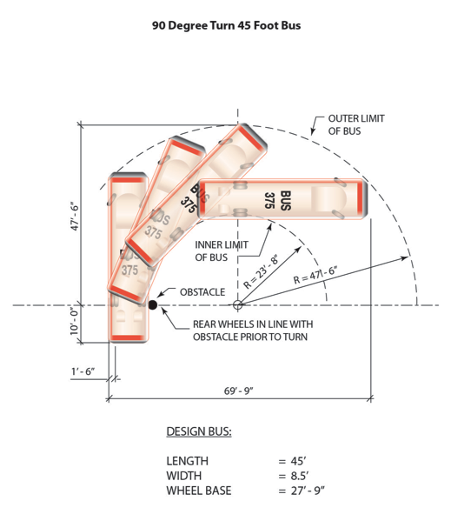
Minimum Turning Radius for 45-Foot Bus Making 90-Degree Turn
(Credit: Michele Weisbart)

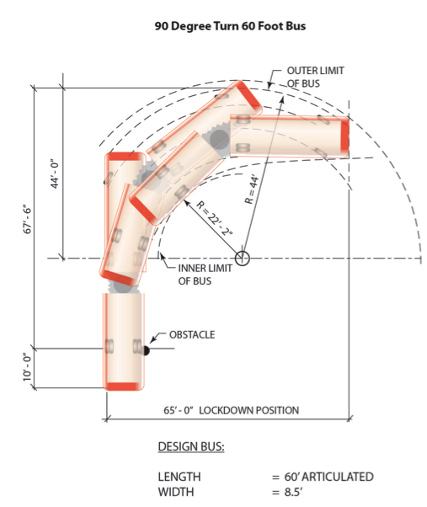
Minimum Turning Radius for 60-Foot Bus Making 90-Degree Turn
(Credit: Michele Weisbart)

URBAN DESIGN
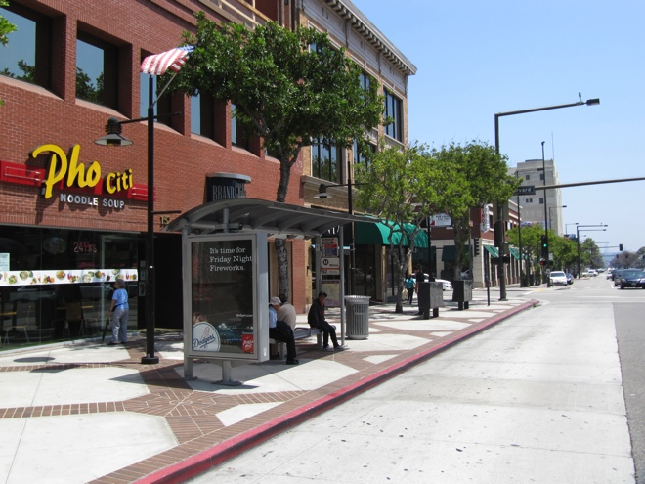
Bus stops should be integrated with
their surroundings: Glendale, CA
(Credit: Ryan Snyder)
Bus stops and amenities vary in complexity and design from standardized off-the-shelf signs and furniture to specially designed elements. The design of the bus stop elements, location of the bus stop in relation to adjacent land uses or activities, and the quality of the roadway’s pedestrian environment contribute to a bus stop’s placemaking. Transit operators like a branded look to their stops so they are easily identified, but often there is room for customized designs to fit in with the neighborhood, with at least some of the features and amenities.

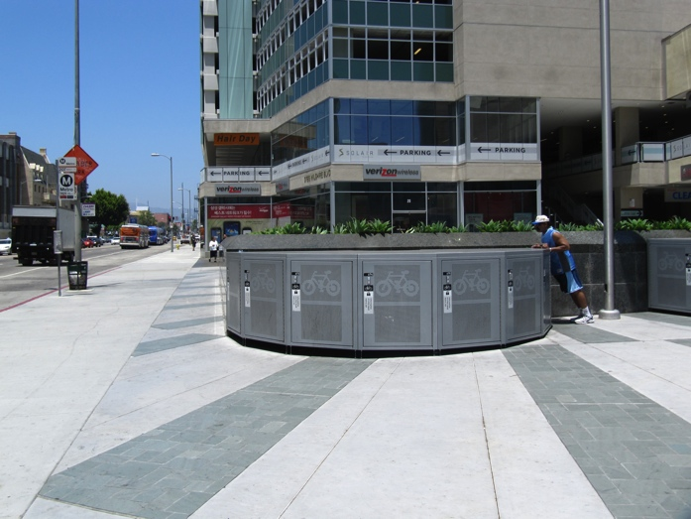BICYCLE CONNECTIONS
Bicycle facilities at transit stations encourage intermodal travel: Los Angeles, CA
(Credit: Ryan Snyder)

Connecting bicycle facilities to transit stations helps extend the trip length for cyclists and reduces automobile travel. Secure bicycle parking must be provided at or within close proximity to a bus stop, preferably sheltered. At a minimum, the accommodations can be bike racks or lockers. Bike stations and automated bicycle parking can be located at areas with high levels of transit and bicycle use.

BUS LANES

Bus lanes provide exclusive or semi-exclusive use for transit vehicles to improve the transit system’s travel time and operating efficiency by separating transit from congested travel lanes. They can be located in an exclusive right-of-way or share a roadway right-of-way. They can be physically separated from other travel lanes or differentiated by lane markings and signs.

Bus lanes can be located within a roadway median or along a curb-side lane, and are identified by lane markings and signs. They should generally be at least 11 feet wide, but where bicycles share the lane with buses, 13 to 15 feet wide is preferred. When creating bus lanes, cities should consider the following:
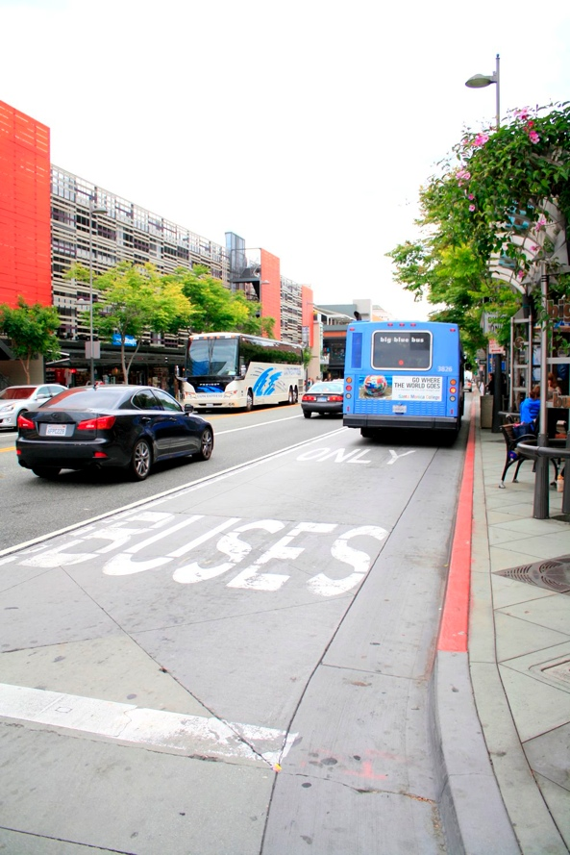
Bus-only lane: Santa Monica, CA
(Credit: Sky Yim)
- Exclusive transit use may be limited to peak travel periods or shared with high-occupancy vehicles.
- On-street parking may be allowed depending on roadway design, especially with bus lanes located in the center of the street.
- A mixed-flow lane or on-street parking may be displaced; this is preferable to adding a lane to an already wide roadway, which increases the crossing distance for pedestrians and creates other problems discussed in other chapters.
- Within a mixed-flow lane, the roadway can be delineated by striping and signs.
- High-occupancy vehicles and/or bicycles may be permitted to use bus lanes.

Pedestrian access to stations becomes an issue when bus lanes are located in roadway medians.

ACCOMODATING LIGHT RAIL, STREET CARS, and BRT

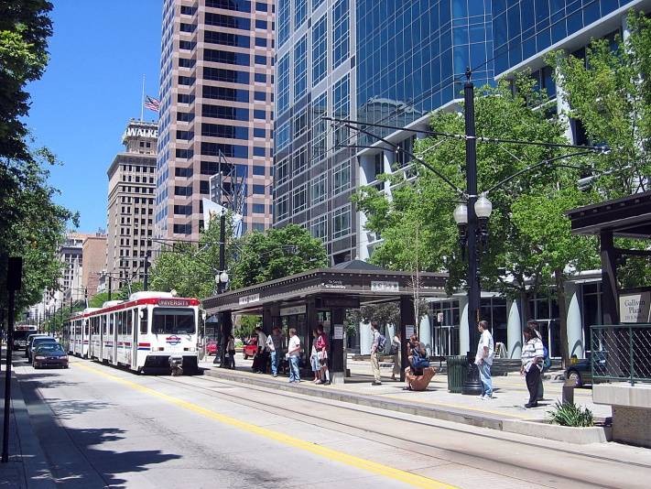
A growing number of streets have light rail lines, street cars, or BRT. These need to be carefully designed into the street.

The various options for accommodating light rail, street cars, and BRT within streets are as follows:

- Center-running
- Two-way split-side, with one direction of transit flow in each direction
- Two-way single-side, with both directions of transit flow on one side of the street right-of-way
Light-rail in urban street: Salt Lake City
(Credit: Paul Zykofsky)
- One-way single-side, with transit running one direction (either with or against the flow of vehicular traffic) and usually operating in a one-way couplet on parallel streets.

For each configuration, transit can operate in a reserved guideway or in mixed street traffic. When installing light rail or street cars within streets, the safety of pedestrians and bicyclists needs to be fully provided for. If poorly designed, these transit lines introduce hazards and serve to divide neighborhoods where crossings are highly limited and/or difficult or inconvenient (see Chapter 7, “Pedestrian Crossings” for more guidance). In 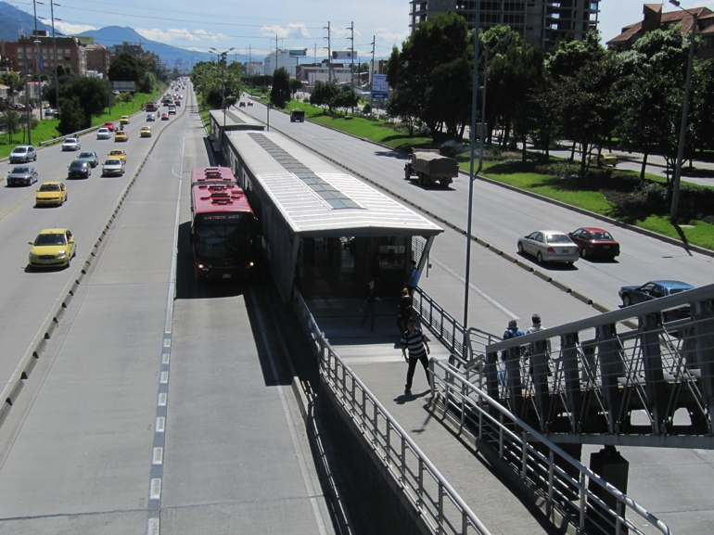general, in areas of high pedestrian activity, the speed of the transit service should be compatible with the speed of pedestrians.
Bus Rapid Transit: Bogota, Colombia
(Credit: Ryan Snyder)

The potential for each configuration is influenced by the street type. Some transit configurations will not work effectively in combination with certain street types. The table below outlines the compatibility of each configuration with the four street types.

Table 9.3 Street Types and Transit Configurations

 | Center Running |  | Two-Way Split Side |  | Two-Way Single Side |  | One-Way Single Side
Street Type | Reserved Guideway | In Street | Reserved Guideway | In Street | Reserved Guideway | In Street | Reserved Guideway | In Street
Boulevard | Y | N | N | Y | Y | N | Y* | Y
Multi-way Boulevard | Y | N* | Y | Y | N | N | Y* | Y
Avenue | Y | Y | Y* | Y | Y* | N | Y | Y
Street | N | Y | Y | Y | N* | N | Y | Y

Notes
Y = Recommended street type/transit configuration combination
N = Not recommended/possible street type/transit configuration combination
*Denotes configurations that mat be possible under certain circumstances, but are not usually optimal
Source: Integration of Transit into Urban Thoroughfare Design, DRAFT White Paper prepared by the Center for Transit-Oriented Development, updated: November 9, 2007.

